TASK REPORT

Music Links Form
& Preview Cards
A responsive web form for submitting and previewing music platform links

1. Objective
To create a web form named musicLinksForm that accepts Spotify, YouTube Music, and Apple Music URLs, validates the submitted links, and displays the accepted links as styled preview cards below the form.

2. Tools and Technologies
- HTML5: defines the form, labels, URL inputs, submit button, and preview section.
- CSS3: styles the page, form, preview cards, spacing, colors, and responsive layouts.
- JavaScript: handles form submission, checks allowed URL domains, and creates preview cards dynamically.
- Visual Studio Code and a web browser: used to edit and test the local HTML page.

3. Implementation Summary
- Project setup: Created an index.html file for the page structure, styles, and script.
- Form creation: Added three fields for Spotify, YouTube Music, and Apple Music URLs, with the required form ID musicLinksForm.
- Validation: Added JavaScript checks so at least one link is required and submitted links must use HTTPS and the appropriate platform domain.
- Preview generation: On submission, JavaScript creates a card for each non-empty accepted URL, including a platform title, short description, and link button.
- Responsive styling: Used CSS Grid and media queries to adapt the card layout for desktop, tablet, and mobile screen sizes.

4. Screenshot of Completed Task
The screenshot below records the page running locally in a browser. The YouTube Music field contains a URL, the success message is visible, and a YouTube Music preview card is displayed.
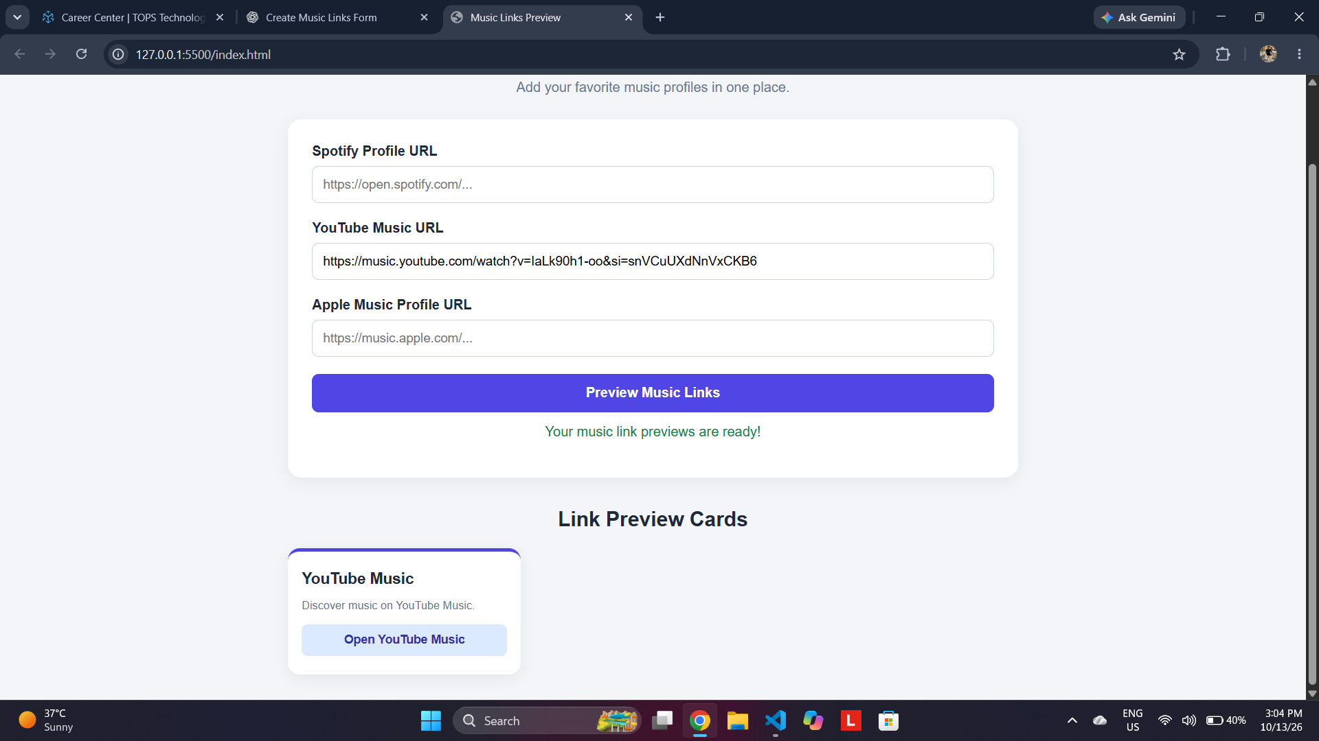
Figure 1. Music Links Preview page in the browser.

5. Testing and Observations
Test | Expected result | Observed / status
Page loads | Form and preview section appear | Visible in screenshot
YouTube Music URL | One preview card is generated | Card displayed
Success feedback | Confirmation message appears | Visible in screenshot
Empty submission | Validation message is shown | To be tested
Invalid domain | URL is rejected | To be tested
Responsive layout | Cards adapt to screen width | CSS breakpoints included; verify at multiple widths

6. Result
The page demonstrates the main workflow: entering a supported music link, submitting the form, and viewing the link in a styled preview card. The supplied screenshot confirms that the form, success message, and YouTube Music preview card are visible. Empty-input handling, invalid-domain handling, and responsive behavior should also be tested before final submission.

7. Conclusion
The task combines semantic HTML, responsive CSS, and JavaScript DOM manipulation to build a simple music-link preview interface. The implementation is organized in a single HTML file and can be run locally in a browser without a server or database.

